Project Report complete

1.INTRODUCTION

1.1Onview

Professional designing process cards

1.2Purpose

Give you a sleek and

Attractive resume, without the

Fuss.

2.Problem Definition & Design

Thinking

2.1Empathy Map

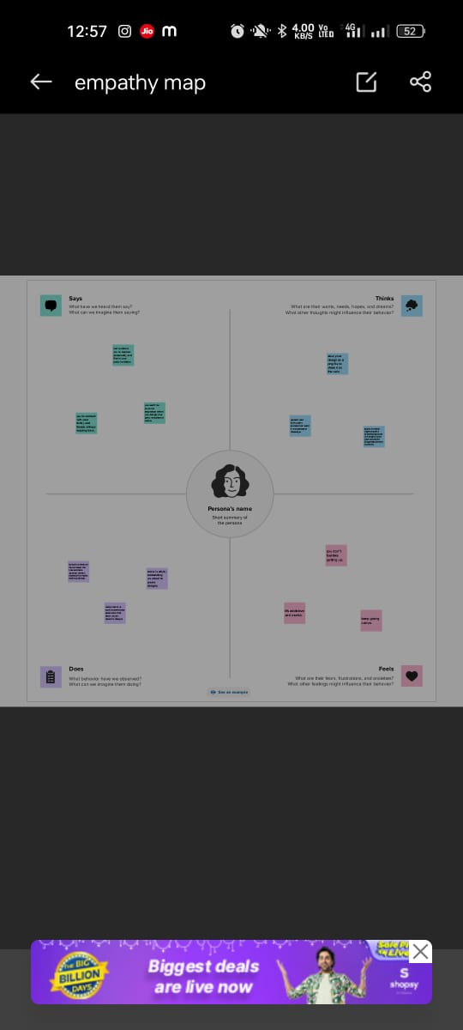

2.2 Ideation&Brainstorming Map

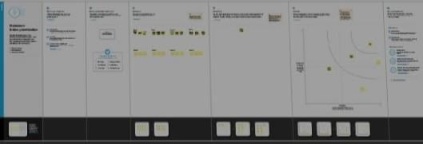

3.RESULT

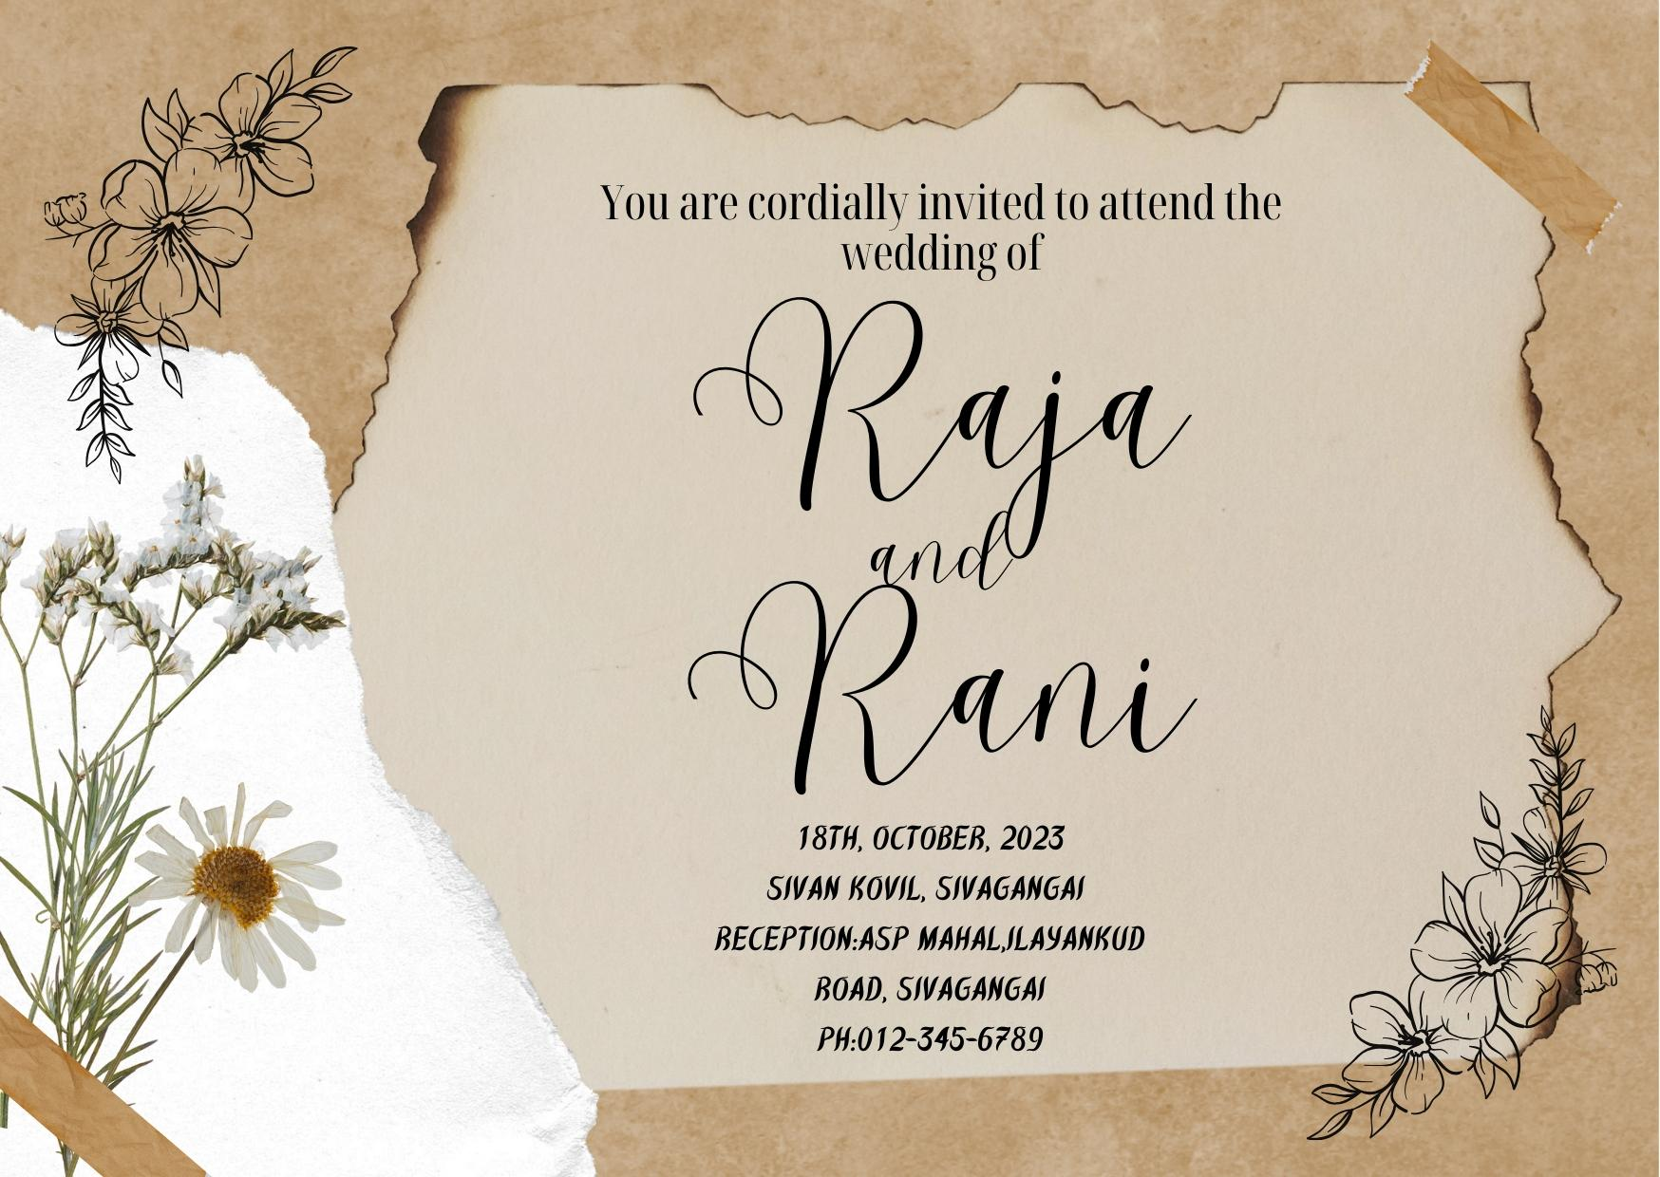

4.ADVANTAGES&DISADVANTAGES

Canva is very simple to use and user friendly :From Layout of the platform to guided templates, basically a drag and drop design platform.

It's disadvantage is although canva's contribution is growing every month, there is a limitation to template designs and stock photography.

5.APPLICATION

A formal invitation letter is written to an honouree so it s

hould contain proper information about the venue, date, etc…of the event.

6.CONCLUSION

We Learn a lot of New things about Editing and Make it useful for others.